**Multilevel Queue Scheduling**

Another class of scheduling algorithms has been created for situations in which processes are easily classified into different groups. For example, a common division is made between foreground (interactive) processes and background (batch) processes. These two types of processes have different response-time requirements and so may have different scheduling needs. In addition, foreground processes may have priority (externally defined) over background processes.

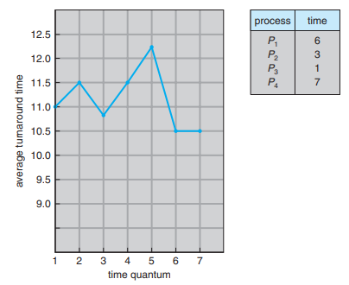

Figure 1.59 How turnaround time varies with the time quantum.

A multilevel queue scheduling algorithm partitions the ready queue into several separate queues (Figure 1.60). The processes are permanently assigned to one queue, generally based on some property of the process, such as memory size, process priority, or process type. Each queue has its own scheduling algorithm. For example, separate queues might be used for foreground and background processes. The foreground queue might be scheduled by an RR algorithm, while the background queue is scheduled by an FCFS algorithm.

In addition, there must be scheduling among the queues, which is commonly implemented as fixed-priority preemptive scheduling. For example, the foreground queue may have absolute priority over the background queue.

Let’s look at an example of a multilevel queue scheduling algorithm with five queues, listed below in order of priority:

1. System processes

2. Interactive processes

3. Interactive editing processes

4. Batch processes

5. Student processes

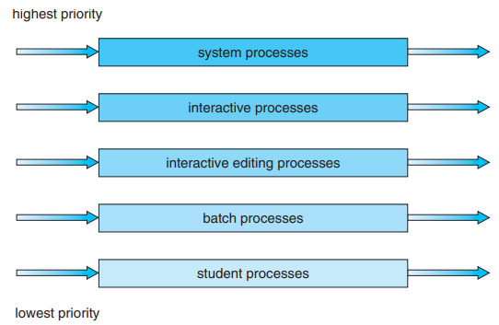

Figure 1.60 Multilevel queue scheduling.

Each queue has absolute priority over lower-priority queues. No process in the batch queue, for example, could run unless the queues for system processes, interactive processes, and interactive editing processes were all empty. If an interactive editing process entered the ready queue while a batch process was running, the batch process would be preempted.

Another possibility is to time-slice among the queues. Here, each queue gets a certain portion of the CPU time, which it can then schedule among its various processes. For instance, in the foreground–background queue example, the foreground queue can be given 80 percent of the CPU time for RR scheduling among its processes, while the background queue receives 20 percent of the CPU to give to its processes on an FCFS basis.

**Multilevel Feedback Queue Scheduling**

Normally, when the multilevel queue scheduling algorithm is used, processes are permanently assigned to a queue when they enter the system. If there are separate queues for foreground and background processes, for example, processes do not move from one queue to the other, since processes do not change their foreground or background nature. This setup has the advantage of low scheduling overhead, but it is inflexible.

The multilevel feedback queue scheduling algorithm, in contrast, allows a process to move between queues. The idea is to separate processes according to the characteristics of their CPU bursts. If a process uses too much CPU time, it will be moved to a lower-priority queue. This scheme leaves I/O-bound and interactive processes in the higher-priority queues. In addition, a process that waits too long in a lower-priority queue may be moved to a higher-priority queue. This form of aging prevents starvation.

For example, consider a multilevel feedback queue scheduler with three queues, numbered from 0 to 2 (Figure 1.61). The scheduler first executes all processes in queue 0. Only when queue 0 is empty will it execute processes in queue 1. Similarly, processes in queue 2 will be executed only if queues 0 and 1 are empty. A process that arrives for queue 1 will preempt a process in queue 2. A process in queue 1 will in turn be preempted by a process arriving for queue 0.

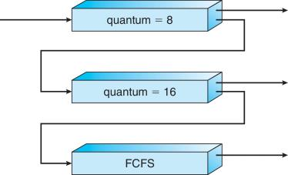

Figure 1.61 Multilevel feedback queues.

A process entering the ready queue is put in queue 0. A process in queue 0 is given a time quantum of 8 milliseconds. If it does not finish within this time, it is moved to the tail of queue 1. If queue 0 is empty, the process at the head of queue 1 is given a quantum of 16 milliseconds. If it does not complete, it is preempted and is put into queue 2. Processes in queue 2 are run on an FCFS basis but are run only when queues 0 and 1 are empty.

This scheduling algorithm gives highest priority to any process with a CPU burst of 8 milliseconds or less. Such a process will quickly get the CPU, finish its CPU burst, and go off to its next I/O burst. Processes that need more than 8 but less than 24 milliseconds are also served quickly, although with lower priority than shorter processes. Long processes automatically sink to queue 2 and are served in FCFS order with any CPU cycles left over from queues 0 and 1.

In general, a multilevel feedback queue scheduler is defined by the following parameters:

• The number of queues

• The scheduling algorithm for each queue

• The method used to determine when to upgrade a process to a higher-priority queue

• The method used to determine when to demote a process to a lower-priority queue

• The method used to determine which queue a process will enter when that process needs service

The definition of a multilevel feedback queue scheduler makes it the most general CPU-scheduling algorithm. It can be configured to match a specific system under design. Unfortunately, it is also the most complex algorithm since defining the best scheduler requires some means by which to select values for all the parameters.

**Thread Scheduling**

We have introduced threads to the process model, distinguishing between user-level and kernel-level threads. On operating systems that support them, it is kernel-level threads—not processes—that are being scheduled by the operating system. User-level threads are managed by a thread library, and the kernel is unaware of them. To run on a CPU, user-level threads must ultimately be mapped to an associated kernel-level thread, although this mapping may be indirect and may use a lightweight process (LWP). In this section, we explore scheduling issues involving user-level and kernel-level threads and offer specific examples of scheduling for Pthreads.

**Contention Scope**

One distinction between user-level and kernel-level threads lies in how they are scheduled. On systems implementing the many-to-one and many-to-many models, the thread library schedules user-level threads to run on an available LWP. This scheme is known as process contention scope (PCS), since competition for the CPU takes place among threads belonging to the same process. (When we say the thread library schedules user threads onto available LWPs, we do not mean that the threads are actually running on a CPU. That would require the operating system to schedule the kernel thread onto a physical CPU.) To decide which kernel-level thread to schedule onto a CPU, the kernel uses system-contention scope (SCS). Competition for the CPU with SCS scheduling takes place among all threads in the system. Systems using the one-to-one model, such as Windows, Linux, and Solaris, schedule threads using only SCS.

Typically, PCS is done according to priority—the scheduler selects the runnable thread with the highest priority to run. User-level thread priorities are set by the programmer and are not adjusted by the thread library, although some thread libraries may allow the programmer to change the priority of a thread. It is important to note that PCS will typically preempt the thread currently running in favor of a higher-priority thread; however, there is no guarantee of time slicing among threads of equal priority.

**Pthread Scheduling**

We have already provided a sample POSIX Pthread program along with an introduction to thread creation with Pthreads. Now, we highlight the POSIX Pthread API that allows specifying PCS or SCS during thread creation. Pthreads identifies the following contention scope values:

**• PTHREAD SCOPE PROCESS schedules threads using PCS scheduling.**

**• PTHREAD SCOPE SYSTEM schedules threads using SCS scheduling.**

On systems implementing the many-to-many model, the PTHREAD SCOPE PROCESS policy schedules user-level threads onto available LWPs. The number of LWPs is maintained by the thread library, perhaps using scheduler activations. The PTHREAD SCOPE SYSTEM scheduling policy will create and bind an LWP for each user-level thread on many-to-many systems, effectively mapping threads using the one-to-one policy.

The Pthread IPC provides two functions for getting—and setting—the contention scope policy:

• pthread attr setscope(pthread attr t *attr, int scope)

• pthread attr getscope(pthread attr t *attr, int *scope)

The first parameter for both functions contains a pointer to the attribute set for the thread. The second parameter for the pthread attr setscope() function is passed either the PTHREAD SCOPE SYSTEM or the PTHREAD SCOPE PROCESS value, indicating how the contention scope is to be set. In the case of pthread attr getscope(), this second parameter contains a pointer to an int value that is set to the current value of the contention scope. If an error occurs, each of these functions returns a nonzero value.

**Multiple-Processor Scheduling**

Our discussion thus far has focused on the problems of scheduling the CPU in a system with a single processor. If multiple CPUs are available, load sharing becomes possible—but scheduling problems become correspondingly more complex. Many possibilities have been tried; and as we saw with single-processor CPU scheduling, there is no one best solution.

Here, we discuss several concerns in multiprocessor scheduling. We concentrate on systems in which the processors are identical—homogeneous —in terms of their functionality. We can then use any available processor to run any process in the queue. Note, however, that even with homogeneous multiprocessors, there are sometimes limitations on scheduling. Consider a system with an I/O device attached to a private bus of one processor. Processes that wish to use that device must be scheduled to run on that processor.

**Approaches to Multiple-Processor Scheduling**

One approach to CPU scheduling in a multiprocessor system has all scheduling decisions**,** I/O processing, and other system activities handled by a single processor—the master server. The other processors execute only user code. This asymmetric multiprocessing is simple because only one processor accesses the system data structures, reducing the need for data sharing.

A second approach uses symmetric multiprocessing (SMP),where each processor is self-scheduling. All processes may be in a common ready queue, or each processor may have its own private queue of ready processes. Regardless, scheduling proceeds by having the scheduler for each processor examine the ready queue and select a process to execute. If we have multiple processors trying to access and update a common data structure, the scheduler must be programmed carefully. We must ensure that two separate processors do not choose to schedule the same process and that processes are not lost from the queue. Virtually all modern operating systems support SMP, including Windows, Linux, and Mac OS X. In the remainder of this section, we discuss issues concerning SMP systems.

**Multicore Processors**

Traditionally, SMP systems have allowed several threads to run concurrently by providing multiple physical processors. However, a recent practice in computer hardware has been to place multiple processor cores on the same physical chip, resulting in a multicore processor. Each core maintains its architectural state and thus appears to the operating system to be a separate physical processor. SMP systems that use multicore processors are faster and consume less power than systems in which each processor has its own physical chip.

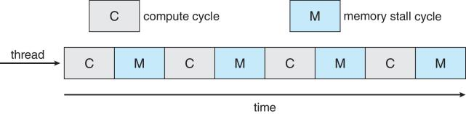

Figure 1.62 Memory stall.

Multicore processors may complicate scheduling issues. Let’s consider how this can happen. Researchers have discovered that when a processor accesses memory, it spends a significant amount of time waiting for the data to become available. This situation, known as a memory stall, may occur for various reasons, such as a cache miss (accessing data that are not in cache memory). Figure 1.62 illustrates a memory stall. In this scenario, the processor can spend up to 50 percent of its time waiting for data to become available from memory. To remedy this situation, many recent hardware designs have implemented multithreaded processor cores in which two (or more) hardware threads are assigned to each core. That way, if one thread stalls while waiting for memory, the core can switch to another thread. Figure 1.63 illustrates a dual-threaded processor core on which the execution of thread 0 and the execution of thread 1 are interleaved. From an operating-system perspective, each hardware thread appears as a logical processor that is available to run a software thread. Thus, on a dual-threaded, dual-core system, four logical processors are presented to the operating system. The UltraSPARC T3 CPU has sixteen cores per chip and eight hardware threads per core. From the perspective of the operating system, there appear to be 128 logical processors.

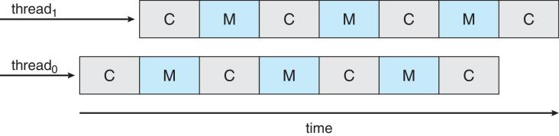

Figure 1.63 Multithreaded multicore system.

In general, there are two ways to multithread a processing core: coarse-grained and fine-grained multithreading. With coarse-grained multithreading, a thread executes on a processor until a long-latency event such as a memory stall occurs. Because of the delay caused by the long-latency event, the processor must switch to another thread to begin execution. However, the cost of switching between threads is high, since the instruction pipeline must be flushed before the other thread can begin execution on the processor core. Once this new thread begins execution, it begins filling the pipeline with its instructions. Fine-grained (or interleaved) multithreading switches between threads at a much finer level of granularity—typically at the boundary of an instruction cycle. However, the architectural design of fine-grained systems includes logic for thread switching. As a result, the cost of switching between threads is small.

Notice that a multithreaded multicore processor actually requires two different levels of scheduling. On one level are the scheduling decisions that must be made by the operating system as it chooses which software thread to run on each hardware thread (logical processor). For this level of scheduling, the operating system may choose any scheduling algorithm. A second level of scheduling specifies how each core decides which hardware thread to run. There are several strategies to adopt in this situation. The UltraSPARC T3, mentioned earlier, uses a simple round robin algorithm to schedule the eight hardware threads to each core. Another example, the Intel Itanium, is a dual-core processor with two hardware-managed threads per core. Assigned to each hardware thread is a dynamic urgency value ranging from 0 to 7, with 0 representing the lowest urgency and 7 the highest. The Itanium identifies five different events that may trigger a thread switch. When one of these events occurs, the thread-switching logic compares the urgency of the two threads and selects the thread with the highest urgency value to execute on the processor core.

**Processor Affinity**

Consider what happens to cache memory when a process has been running on a specific processor. The data most recently accessed by the process populate the cache for the processor. As a result, successive memory accesses by the process are often satisfied in cache memory. Now consider what happens if the process migrates to another processor. The contents of cache memory must be invalidated for the first processor, and the cache for the second processor must be repopulated. Because of the high cost of invalidating and repopulating caches, most SMP systems try to avoid migration of processes from one processor to another and instead attempt to keep a process running on the same processor. This is known as processor affinity—that is, a process has an affinity for the processor on which it is currently running

Processor affinity takes several forms. When an operating system has a policy of attempting to keep a process running on the same processor—but not guaranteeing that it will do so—we have a situation known as soft affinity. Here, the operating system will attempt to keep a process on a single processor, but it is possible for a process to migrate between processors. In contrast, some systems provide system calls that support hard affinity, thereby allowing a process to specify a subset of processors on which it may run. Many systems provide both soft and hard affinity. For example, Linux implements soft affinity, but it also provides the sched setaffinity() system call, which supports hard affinity.

The main-memory architecture of a system can affect processor affinity issues. Figure 1.64 illustrates an architecture featuring non-uniform memory access (NUMA), in which a CPU has faster access to some parts of main memory than to other parts. Typically, this occurs in systems containing combined CPU and memory boards. The CPUs on a board can access the memory on that board faster than they can access memory on other boards in the system. If the operating system’s CPU scheduler and memory-placement algorithms work together, then a process that is assigned affinity to a particular CPU can be allocated memory on the board where that CPU resides. This example also shows that operating systems are frequently not as cleanly defined and implemented as described in operating-system textbooks. Rather, the “solid lines” between sections of an operating system are frequently only “dotted lines,” with algorithms creating connections in ways aimed at optimizing performance and reliability.

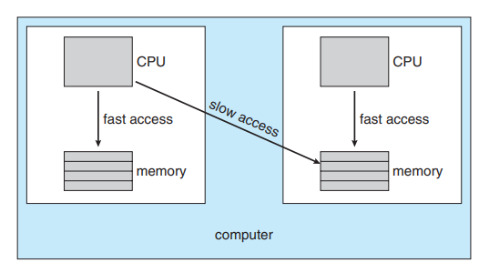

Figure 1.64 NUMA and CPU scheduling.

**Load Balancing**

On SMP systems, it is important to keep the workload balanced among all processors to fully utilize the benefits of having more than one processor.

Otherwise, one or more processors may sit idle while other processors have high workloads, along with lists of processes awaiting the CPU. Load balancing attempts to keep the workload evenly distributed across all processors in an SMP system. It is important to note that load balancing is typically necessary only on systems where each processor has its own private queue of eligible processes to execute. On systems with a common run queue, load balancing is often unnecessary, because once a processor becomes idle, it immediately extracts a runnable process from the common run queue. It is also important to note, however, that in most contemporary operating systems supporting SMP, each processor does have a private queue of eligible processes.

There are two general approaches to load balancing: push migration and pull migration. With push migration, a specific task periodically checks the load on each processor and—if it finds an imbalance—evenly distributes the load by moving (or pushing) processes from overloaded to idle or less-busy processors. Pull migration occurs when an idle processor pulls a waiting task from a busy processor. Push and pull migration need not be mutually exclusive and are in fact often implemented in parallel on load-balancing systems. For example, the Linux scheduler and the ULE scheduler available for FreeBSD systems implement both techniques.

Interestingly, load balancing often counteracts the benefits of processor affinity. That is, the benefit of keeping a process running on the same processor is that the process can take advantage of its data being in that processor’s cache memory. Either pulling or pushing a process from one processor to another removes this benefit. As is often the case in systems engineering, there is no absolute rule concerning what policy is best. Thus, in some systems, an idle processor always pulls a process from a non-idle processor. In other systems, processes are moved only if the imbalance exceeds a certain threshold.

**Real-Time CPU Scheduling**

CPU scheduling for real-time operating systems involves special issues. In general, we can distinguish between soft real-time systems and hard real-time systems. Soft real-time systems provide no guarantee as to when a critical real-time process will be scheduled. They guarantee only that the process will be given preference over noncritical processes. Hard real-time systems have stricter requirements. A task must be serviced by its deadline; service after the deadline has expired is the same as no service at all. In this section, we explore several issues related to process scheduling in both soft and hard real-time operating systems.

**Minimizing Latency**

Consider the event-driven nature of a real-time system. The system is typically waiting for an event in real time to occur. Events may arise either in software —as when a timer expires—or in hardware—as when a remote-controlled vehicle detects that it is approaching an obstruction. When an event occurs, the system must respond to and service it as quickly as possible. We refer to event latency as the amount of time that elapses from when an event occurs to when it is serviced (Figure 1.65).

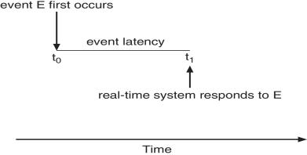

Figure 1.65 Event latency.

Usually, different events have different latency requirements. For example, the latency requirement for an antilock brake system might be 3 to 5 milliseconds. That is, from the time a wheel first detects that it is sliding, the system controlling the antilock brakes has 3 to 5 milliseconds to respond to and control the situation. Any response that takes longer might result in the automobile’s veering out of control. In contrast, an embedded system controlling radar in an airliner might tolerate a latency period of several seconds.

Two types of latencies affect the performance of real-time systems:

1. Interrupt latency

2. Dispatch latency

Interrupt latency refers to the period of time from the arrival of an interrupt at the CPU to the start of the routine that services the interrupt. When an interrupt occurs, the operating system must first complete the instruction it is executing and determine the type of interrupt that occurred. It must then save the state of the current process before servicing the interrupt using the specific interrupt service routine (ISR). The total time required to perform these tasks is the interrupt latency (Figure 1.66). Obviously, it is crucial for real time operating systems to minimize interrupt latency to ensure that real-time tasks receive immediate attention. Indeed, for hard real-time systems, interrupt latency must not simply be minimized, it must be bounded to meet the strict requirements of these systems.

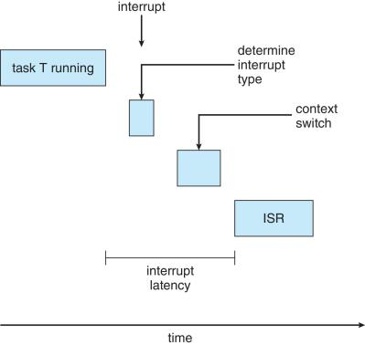

Figure 1.66 Interrupt latency

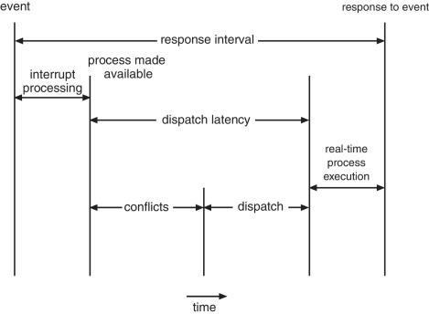

Figure 1.67 Dispatch latency.

One important factor contributing to interrupt latency is the amount of time interrupts may be disabled while kernel data structures are being updated. Real-time operating systems require that interrupts be disabled for only very short periods of time.

The amount of time required for the scheduling dispatcher to stop one process and start another is known as dispatch latency. Providing real-time tasks with immediate access to the CPU mandates that real-time operating systems minimize this latency as well. The most effective technique for keeping dispatch latency low is to provide preemptive kernels.

In Figure 1.67, we diagram the makeup of dispatch latency. The conflict phase of dispatch latency has two components:

1. Preemption of any process running in the kernel

2. Release by low-priority processes of resources needed by a high-priority process

As an example, in Solaris, the dispatch latency with preemption disabled is over a hundred milliseconds. With preemption enabled, it is reduced to less than a millisecond.

**Priority-Based Scheduling**

The most important feature of a real-time operating system is to respond immediately to a real-time process as soon as that process requires the CPU.

As a result, the scheduler for a real-time operating system must support a priority-based algorithm with preemption. Recall that priority-based scheduling algorithms assign each process a priority based on its importance; more important tasks are assigned higher priorities than those deemed less important. If the scheduler also supports preemption, a process currently running on the CPU will be preempted if a higher-priority process becomes available to run.

Preemptive, priority-based scheduling algorithms presents examples of the soft real-time scheduling features of the Linux, Windows, and Solaris operating systems. Each of these systems assigns real-time processes the highest scheduling priority. For example, Windows has 32 different priority levels. The highest levels—priority values 16 to 31—are reserved for real-time processes. Solaris and Linux have similar prioritization schemes.

Note that providing a preemptive, priority-based scheduler only guarantees soft real-time functionality. Hard real-time systems must further guarantee that real-time tasks will be serviced in accord with their deadline requirements, and making such guarantees requires additional scheduling features. In the remainder of this section, we cover scheduling algorithms appropriate for hard real-time systems.

Before we proceed with the details of the individual schedulers, however, we must define certain characteristics of the processes that are to be scheduled. First, the processes are considered periodic. That is, they require the CPU at constant intervals (periods). Once a periodic process has acquired the CPU, it has a fixed processing time t, a deadline d by which it must be serviced by the CPU, and a period p. The relationship of the processing time, the deadline, and the period can be expressed as 0 ≤ t ≤ d ≤ p. The rate of a periodic task is 1/p. Figure 1.68 illustrates the execution of a periodic process over time. Schedulers can take advantage of these characteristics and assign priorities according to a process’s deadline or rate requirements.

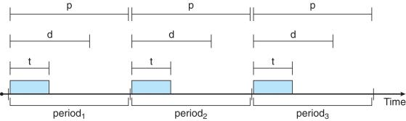

Figure 1.68 Periodic task.

What is unusual about this form of scheduling is that a process may have to announce its deadline requirements to the scheduler. Then, using a technique known as an admission-control algorithm, the scheduler does one of two things. It either admits the process, guaranteeing that the process will complete on time, or rejects the request as impossible if it cannot guarantee that the task will be serviced by its deadline.

**Algorithm Evaluation**

How do we select a CPU-scheduling algorithm for a particular system? There are many scheduling algorithms, each with its own parameters. As a result, selecting an algorithm can be difficult.

The first problem is defining the criteria to be used in selecting an algorithm. Criteria are often defined in terms of CPU utilization, response time, or throughput. To select an algorithm, we must first define the relative importance of these elements. Our criteria may include several measures, such as these:

• Maximizing CPU utilization under the constraint that the maximum response time is 1 second

• Maximizing throughput such that turnaround time is (on average) linearly proportional to total execution time.

Once the selection criteria have been defined, we want to evaluate the algorithms under consideration. We next describe the various evaluation methods we can use.

**Deterministic Modeling**

One major class of evaluation methods is analytic evaluation. Analytic evaluation uses the given algorithm and the system workload to produce a formula or number to evaluate the performance of the algorithm for that workload.

Deterministic modeling is one type of analytic evaluation. This method takes a particular predetermined workload and defines the performance of each algorithm for that workload. For example, assume that we have the workload shown below. All five processes arrive at time 0, in the order given, with the length of the CPU burst given in milliseconds:

Process Burst Time

P1 10

P2 29

P3 3

P4 7

P5 12

Consider the FCFS, SJF, and RR (quantum = 10 milliseconds) scheduling algorithms for this set of processes. Which algorithm would give the minimum average waiting time?

For the FCFS algorithm, we would execute the processes as

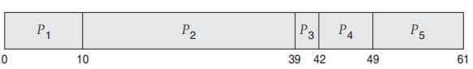

The waiting time is 0 milliseconds for process P1, 10 milliseconds for process P2, 39 milliseconds for process P3, 42 milliseconds for process P4, and 49 milliseconds for process P5. Thus, the average waiting time is (0 + 10 + 39 + 42 + 49)/5 = 28 milliseconds.

With non-preemptive SJF scheduling, we execute the processes as

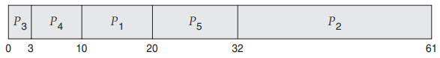

The waiting time is 10 milliseconds for process P1, 32 milliseconds for process P2, 0 milliseconds for process P3, 3 milliseconds for process P4, and 20 milliseconds for process P5. Thus, the average waiting time is (10 + 32 + 0 + 3 + 20)/5 = 13 milliseconds.

With the RR algorithm, we execute the processes as

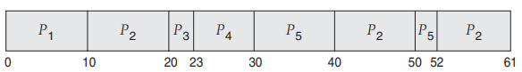

The waiting time is 0 milliseconds for process P1, 32 milliseconds for process P2, 20 milliseconds for process P3, 23 milliseconds for process P4, and 40 milliseconds for process P5. Thus, the average waiting time is (0 + 32 + 20 + 23 + 40)/5 = 23 milliseconds.

We can see that, in this case, the average waiting time obtained with the SJF policy is less than half that obtained with FCFS scheduling; the RR algorithm gives us an intermediate value.

Deterministic modeling is simple and fast. It gives us exact numbers, allowing us to compare the algorithms. However, it requires exact numbers for input, and its answers apply only to those cases. The main uses of deterministic modeling are in describing scheduling algorithms and providing examples. In cases where we are running the same program over and over again and can measure the program’s processing requirements exactly, we may be able to use deterministic modeling to select a scheduling algorithm. Furthermore, over a set of examples, deterministic modeling may indicate trends that can then be analyzed and proved separately. For example, it can be shown that, for the environment described (all processes and their times available at time 0), the SJF policy will always result in the minimum waiting time.

**Queueing Models**

On many systems, the processes that are run vary from day to day, so there is no static set of processes (or times) to use for deterministic modeling. What can be determined, however, is the distribution of CPU and I/O bursts. These distributions can be measured and then approximated or simply estimated. The result is a mathematical formula describing the probability of a particular CPU burst. Commonly, this distribution is exponential and is described by its mean. Similarly, we can describe the distribution of times when processes arrive in the system (the arrival-time distribution). From these two distributions, it is possible to compute the average throughput, utilization, waiting time, and so on for most algorithms.

The computer system is described as a network of servers. Each server has a queue of waiting processes. The CPU is a server with its ready queue, as is the I/O system with its device queues. Knowing arrival rates and service rates, we can compute utilization, average queue length, average wait time, and so on. This area of study is called queueing-network analysis.

As an example, let n be the average queue length (excluding the process being serviced), let W be the average waiting time in the queue, and let λ be the average arrival rate for new processes in the queue (such as three processes per second). We expect that during the time W that a process waits, *λ* × W new processes will arrive in the queue. If the system is in a steady state, then the number of processes leaving the queue must be equal to the number of processes that arrive. Thus,

n = λ × W.

This equation, known as Little’s formula, is particularly useful because it is valid for any scheduling algorithm and arrival distribution.

We can use Little’s formula to compute one of the three variables if we know the other two. For example, if we know that 7 processes arrive every second (on average) and that there are normally 14 processes in the queue, then we can compute the average waiting time per process as 2 seconds.

Queueing analysis can be useful in comparing scheduling algorithms, but it also has limitations. At the moment, the classes of algorithms and distributions that can be handled are fairly limited. The mathematics of complicated algorithms and distributions can be difficult to work with. Thus, arrival and service distributions are often defined in mathematically tractable —but unrealistic—ways. It is also generally necessary to make a number of independent assumptions, which may not be accurate. As a result of these difficulties, queueing models are often only approximations of real systems, and the accuracy of the computed results may be questionable.

**Simulations**

To get a more accurate evaluation of scheduling algorithms, we can use simulations. Running simulations involves programming a model of the computer system. Software data structures represent the major components of the system. The simulator has a variable representing a clock. As this variable’s value is increased, the simulator modifies the system state to reflect the activities of the devices, the processes, and the scheduler. As the simulation executes, statistics that indicate algorithm performance are gathered and printed.

The data to drive the simulation can be generated in several ways. The most common method uses a random-number generator that is programmed to generate processes, CPU burst times, arrivals, departures, and so on, according to probability distributions. The distributions can be defined mathematically (uniform, exponential, Poisson) or empirically. If a distribution is to be defined empirically, measurements of the actual system under study are taken. The results define the distribution of events in the real system; this distribution can then be used to drive the simulation.

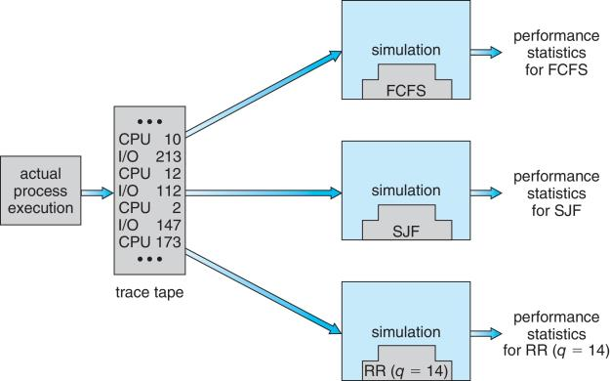

Figure 1.69 Evaluation of CPU schedulers by simulation.

A distribution-driven simulation may be inaccurate, however, because of relationships between successive events in the real system. The frequency distribution indicates only how many instances of each event occur; it does not indicate anything about the order of their occurrence. To correct this problem, we can use trace tapes. We create a trace tape by monitoring the real system and recording the sequence of actual events (Figure 1.69). We then use this sequence to drive the simulation. Trace tapes provide an excellent way to compare two algorithms on exactly the same set of real inputs. This method can produce accurate results for its inputs.

Simulations can be expensive, often requiring hours of computer time. A more detailed simulation provides more accurate results, but it also takes more computer time. In addition, trace tapes can require large amounts of storage space. Finally, the design, coding, and debugging of the simulator can be a major task.

**Implementation**

Even a simulation is of limited accuracy. The only completely accurate way to evaluate a scheduling algorithm is to code it up, put it in the operating system, and see how it works. This approach puts the actual algorithm in the real system for evaluation under real operating conditions.

The major difficulty with this approach is the high cost. The expense is incurred not only in coding the algorithm and modifying the operating system to support it (along with its required data structures) but also in the reaction of the users to a constantly changing operating system. Most users are not interested in building a better operating system; they merely want to get their processes executed and use their results. A constantly changing operating system does not help the users to get their work done.

Another difficulty is that the environment in which the algorithm is used will change. The environment will change not only in the usual way, as new programs are written and the types of problems change, but also as a result of the performance of the scheduler. If short processes are given priority, then users may break larger processes into sets of smaller processes. If interactive processes are given priority over non-interactive processes, then users may switch to interactive use.

For example, researchers designed one system that classified interactive and non-interactive processes automatically by looking at the amount of terminal I/O. If a process did not input or output to the terminal in a 1-second interval, the process was classified as non-interactive and was moved to a lower-priority queue. In response to this policy, one programmer modified his programs to write an arbitrary character to the terminal at regular intervals of less than 1 second. The system gave his programs a high priority, even though the terminal output was completely meaningless.

The most flexible scheduling algorithms are those that can be altered by the system managers or by the users so that they can be tuned for a specific application or set of applications. A workstation that performs high-end graphical applications, for instance, may have scheduling needs different from those of a Web server or file server. Some operating systems— particularly several versions of UNIX—allow the system manager to fine-tune the scheduling parameters for a particular system configuration.